Sudan

## Freedom House political status

The data set shows the Freedom House political scores and status of the country each year.

## # A tibble: 20 x 5  
## country iso3c date mean status   
## <chr> <chr> <dbl> <dbl> <chr>   
## 1 Sudan SDN 1996 7 Not Free  
## 2 Sudan SDN 1998 7 Not Free  
## 3 Sudan SDN 2000 7 Not Free  
## 4 Sudan SDN 2002 7 Not Free  
## 5 Sudan SDN 2003 7 Not Free  
## 6 Sudan SDN 2004 7 Not Free  
## 7 Sudan SDN 2005 7 Not Free  
## 8 Sudan SDN 2006 7 Not Free  
## 9 Sudan SDN 2007 7 Not Free  
## 10 Sudan SDN 2008 7 Not Free  
## 11 Sudan SDN 2009 7 Not Free  
## 12 Sudan SDN 2010 7 Not Free  
## 13 Sudan SDN 2011 7 Not Free  
## 14 Sudan SDN 2011 7 Not Free  
## 15 Sudan SDN 2012 7 Not Free  
## 16 Sudan SDN 2013 7 Not Free  
## 17 Sudan SDN 2014 7 Not Free  
## 18 Sudan SDN 2015 7 Not Free  
## 19 Sudan SDN 2016 7 Not Free  
## 20 Sudan SDN 2017 7 Not Free

## Freedom House classification of political change

The data set shows the GDP growth and the ecomic growth classification of the country each year.

## # A tibble: 20 x 4  
## country iso3c date politicalChangeFH  
## <chr> <chr> <dbl> <chr>   
## 1 Sudan SDN 1996 no change   
## 2 Sudan SDN 1998 no change   
## 3 Sudan SDN 2000 no change   
## 4 Sudan SDN 2002 no change   
## 5 Sudan SDN 2003 no change   
## 6 Sudan SDN 2004 no change   
## 7 Sudan SDN 2005 no change   
## 8 Sudan SDN 2006 no change   
## 9 Sudan SDN 2007 no change   
## 10 Sudan SDN 2008 no change   
## 11 Sudan SDN 2009 no change   
## 12 Sudan SDN 2010 no change   
## 13 Sudan SDN 2011 no change   
## 14 Sudan SDN 2011 no change   
## 15 Sudan SDN 2012 no change   
## 16 Sudan SDN 2013 no change   
## 17 Sudan SDN 2014 no change   
## 18 Sudan SDN 2015 no change   
## 19 Sudan SDN 2016 no change   
## 20 Sudan SDN 2017 no change

## Freedom House score trend

The plot shows the Freedom House scores trend of the country.

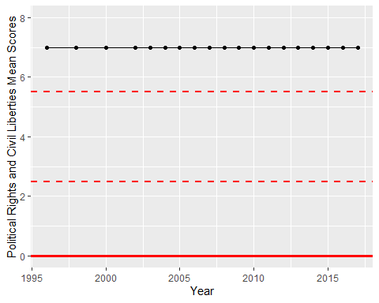

Freedom House Score Trend